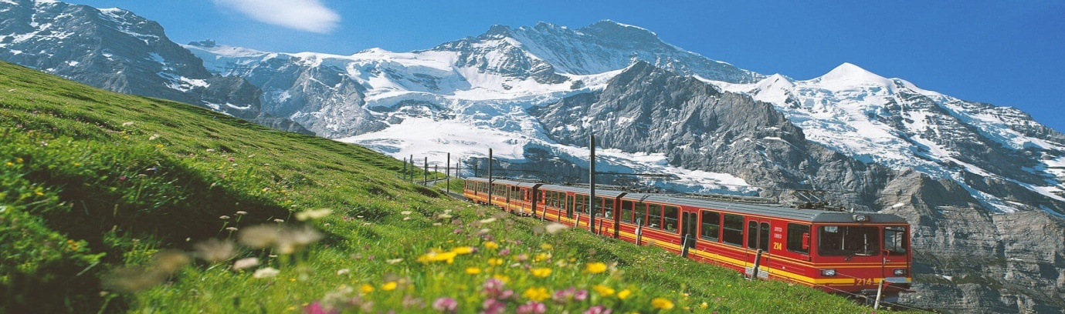
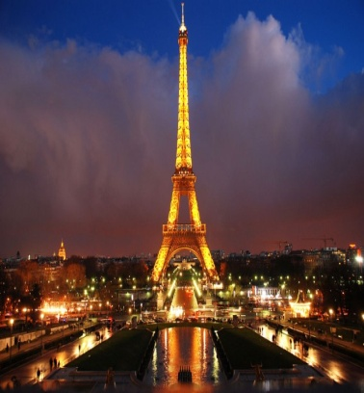
SWITZERLAND AND PARIS 7 Nights / 8Days
Day 01 | Fly for Paris. Arrive Paris. Transfer to the Hotel. Evening free at Leisure or optional tour to the famous LIDO SHOW or you may enjoy a CRUISE on Seine river. Overnight the Hotel.
Day 02 | After Breakfast proceed for Paris City Tour. Visit Notre Dame Cathedral, Champs Elysees , Enjoy the Eiffel Tower. Overnight at the Hotel.
Day 03 | After Breakfast full day tour to the Adventurous and fun filled EURO DISNEY (DISNEY LAND). Overnight at the hotel.
Day 04 | After Breakfast Check out and transfer to Switzerland ( Interlaken ). Check in and overnight at the hotel.
Day 05 | After breakfast start your tour to go to the TOP OF EUROPE – JUNFRAOJOCH. Filled with snow at a height overlooking the mountains. Back to Hotel and overnight at the hotel.
Day 06 | After Breakfast transfer to Lucerne. Day free at leisure. Overnight at the Hotel.
Day 07 | After Breakfast enjoy your tour to Mt. TITLIS with cable car ride. Enjoy the 360 degree view over Alps from the ROTAIR the worlds first of its kind. Enjoy the various Snow activities and sports. Back to hotel. Overnight at the hotel.
Day 08 | After Early Breakfast transfer to Zurich to Board your flight to India.

Package includes :
- Return Air Ticket with taxes ( Ex – Delhi )
- Daily Breakfast
- Accommodation on Twin / Triple Share basis
- All Transfer and sightseeing as per Itinerary on SIC basis
- Entrance fees for places mentioned in the Itinerary
- Driver / Guide at Select Places

