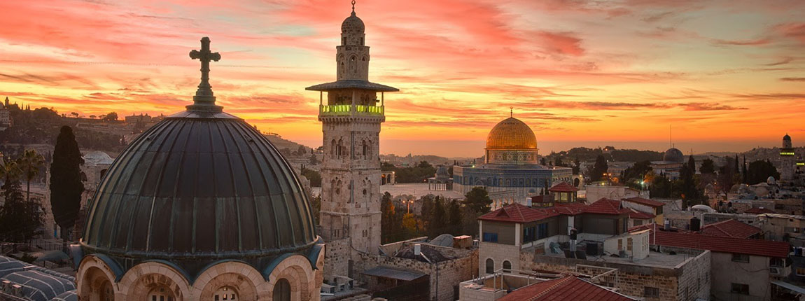

HOLY LANDTOUR

Day 01 | Fly for Amman from Delhi. Arrive Amman. After Immigration meet Guide at the Airport exit and transfer to your Hotel. Day free at leisure. Overnight at the Hotel.
Day 02 | After Breakfast…. Start your half day city tour of the Kingdom of Jordon, visit Machaerus the hilltop palace and proceed to the imprisonment & execution place of John the Baptist and then visit Mt. Nebo. Explore the Dead Sea, the lowest point of Earth and amazingly float in the salty and mineral rich water. Transfer to your Hotel Overnight at Amman. ( Includes Lunch and Dinner )
Day 03 | After Breakfast pick up for a full day tour to visit the wonder of the world PETRA. Transfer to Hotel Overnight at the hotel. ( Includes Lunch and Dinner )
Day 04 | After Breakfast transfer to Israel by Coach. Immigration at Israel Border and En-route sightseeing of Nazareth, where Jesus has spend his boyhood and lived with Joseph and Mary, the Basilica of Annunciation including St. Joseph the Carpenter Church, proceed to KANA where Jesus did his first miracle to transfer Water into Wine. Transfer to your Hotel at NAZARETH. Overnight at the Hotel. ( Includes Lunch and Dinner )
Day 05 | After Breakfast Check out early morning and proceed to Mt.Tabor and Basilica of the Transfiguration. Proceed to CAPERNAUM, the Town of Jesus. Further head to Tabgha and visit the Church of Multiplication and Church St.Peters Primacy. Proceed to BETHLEHEM via Haifa - Tel - Aviv . Visit Mt. Carmel, Stella Maris Church and Bahai Garden at Haifa, enroute Roman Water, Aqueduct in Caesarea, Jafa, St.Peters Church. Arrive and Overnight at Bethlehem Hotel. ( Includes Lunch and Dinner )
Day 06 | After Breakfast explore Bethlehem the land of Epoch, Visit Holy Shrine in Church of Nativity the Birth place of JESUS CHRIST, Star of Bethlehem, Grotto of Manger, Chappel of St. Catherine , The Grotto of Jerome, etc. Proceed to Ein Kareen the Birth place of John the Baptist, drive to Mt. Zion in Jerusalem to visit the Upper Room where the Last Supper of Jesus took place and the Dormition Abbey from where Mother Mary ascended to Heaven. Transfer & Overnight at Bethlehem. ( Includes Lunch and Dinner )
Day 07 | After Breakfast tour to Mt. of Olives. Enjoy the panoramic view of Jerusalem from the mountain top from where Jesus ascended to Heaven, visit the Pattern of Noster, the place where Jesus taught to his disciples, visit the Church of Dominus Flevit then proceed further to Garden of Gethsemane where Jesus was captured by the Romans after he was betrayed by Judas, visit Basilica of The Agony ( Church of All Nations ). Explore the Old city of Jerusalem. Visit Lions Gate, St. Annies Church, Pool of Bethesda. Finally visit the Golgotha & the Holy Sepulchre Church and the Empty Tomb of Jesus / Garden Tomb and the Cardo and Jewish Quarter to see Walling Wall. From here see the Panoramic view of the Mosque of Omar. Transfer and Overnight at the Hotel. ( Includes Lunch and Dinner )
Day 08 | After Breakfast Tour ENDS and DEPARTURE  - OR –  You may proceed for an Extension tour to Egypt as below :  Check out from Hotel and proceed to Taba Border to cross over to Egypt. After completion of Border crossing formalities drive to Hotel at Taba. Overnight at Hotel
Day 09 | After Breakfast check out and Proceed fore CAIRO, En-route St. Catherine Monastery, visit Marah and pass over under water tunnel in Suez canal ( The biggest man made canal in the world ). Check in to Cairo hotel. Overnight at the hotel. ( Includes Lunch and Dinner )
Day 10 | After Breakfast full day tour of Cairo. Visit Holy Family Church, Hanging Church etc. and then drive to Giza to visit the most famous Pyramid and Sphinx and then onto Papyrus and Perfume factory. Further proceed to Cairo Museum / Pharaonic Village. In the evening enjoy nile Cruise with Dinner ( Optional ). ( Includes Lunch )
Day 11 | After Breakfast Check out and drive to Cairo International Airport to Fly for India

Package Includes:
- Return Air Ticket ( Ex – Delhi )
- Accommodation on twin sharing basis ( 3 category hotel )
- Daily Breakfast , Lunch & Dinner
- English speaking Guide throughout the tour
- All transfers by AC Coach on SIC basis
- Sightseeing and All Entrance fees included as per the itinerary
- Cross Border Taxes
Package Excludes :
- Travel Insurance
- VISA Fees
- Personal food Drinks etc
- Tips
- Laundry Telephone Porter and such others

(*Extension to Egypt will cost extra.)

