VIETNAM – CAMBODIA HIGHLIGHTS
09 DAYS / 08 NIGHTS

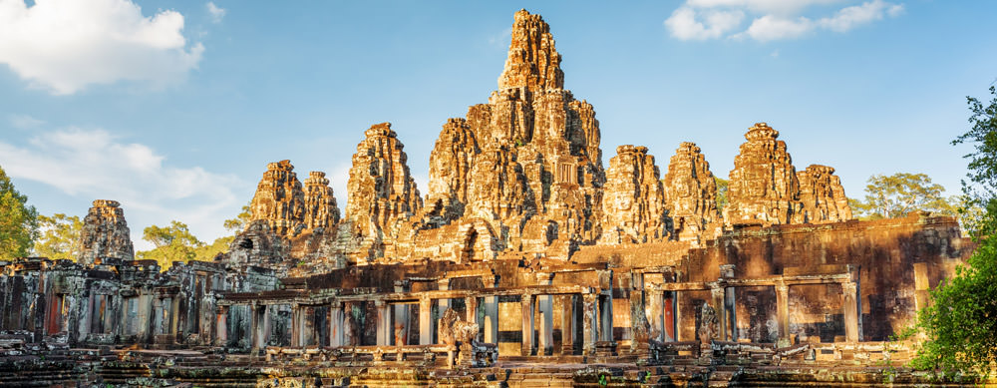
Day 1 | Hanoi arrival (-/ L/ D)  - Xin chao! Welcome to Hanoi, Vietnam. You are greeted by your guide and driver at Noi Bai International airport for your transfer to the hotel. (check in after 14:00)  - Hanoi, one of Asia’s most enchanting cities, full of culture, history and the engaging contradictions of a rapidly developing and deeply traditional society.  - Lunch at Indian Restaurant  - In the afternoon, we will transfer to city center to visit Hoan Kiem Lake, Ngoc Son Temple.  - Visit and shopping at the Old Quarter, Dong Xuan Market.  - Dinner at Indian restaurant.  - Overnight in Hanoi
Day 2 | Hanoi city tour full day (B/L/D)  - Breakfast at hotel.  - 08:00, guide pick up at hotel to take you for a full day sight-seeing and visit some of the most attractive destinations in Hanoi.  - First to visit Tran Quoc Pagoda in West Lake.  - Not far from the pagoda is Ho Chi Minh complex: Ho Chi Minh President Palace, Ho Chi Minh’s house on stilt and One Pillar Pagoda.  - Then visit the Temple of Literature – the first university of Vietnam.  - Lunch at Indian restaurant.  - After lunch, visit the Ethnology Museum – one of the most attractive museums in Hanoi to learn about 54 ethnic minority groups in Vietnam.  - Close the day with a Water Puppet Show  - Dinner at Indian restaurant.  - Overnight in Hanoi.  Notes:  - Ho Chi Minh Mausoleum is closed on Mondays, Fridays, all afternoons  - Ho Chi Minh Mausoleum is also closed on Sep – Nov every year for renovation activities  - Vietnam Ethnology is closed on all Mondays and during Vietnamese Traditional Lunar New Year  - If your travel date falls on any of these days, we will switch it to the next day or find alternative options for you
Day 3 | Hanoi – Halong Bay overnight on cruise (B/L/D)  - This morning transfer from your hotel in Hanoi to Halong City, the drive takes about 4 hours, stopping off for a refreshment break en route.  - On arrival, the junk crew welcomes you on board the cruise to explore the bay. Lunch is served on board  - We will spend the rest of the day cruising around the myriad of tiny islands and exploring the many grottoes created by the wind and the waves.  - Cooking demonstration on board.  - Dinner on board  - Overnight on board.  Notes:  - Cruise itinerary is subject to change due to the weather conditions  - Meals on the cruise are local food
Day 4 | Halong Bay – Hanoi – Ho Chi Minh City by flight (Brunch/D)  - Early start for a Tai Chi demonstration on the sundeck; tea and coffee available.  - Light breakfast will be served in the restaurant  - Continue explore the Halong Bay  - Back to main boat for check out: please put your baggage out to the corridor and settle your bill at reception.  - Brunch is served atfer that  - Arrival at habour at noontime, disembark cruise then take transfer back to Noi Bai international airport for flight to Ho Chi Minh City.  - Upon arrival at Tan Son Nhat international airport, local guide pick up and transfer to have dinner at Indian restaurant.  - Overnight in Ho Chi Minh City.
Day 5 | Cu Chi Tunnels – Ho Chi Minh City tour (B/L/D)  - After breakfast, depart Ho Chi Minh City, you head out to Cu Chi Tunnels - an elaborate underground network of 250 km of tunnels and chambers below the city. They were the location of several military campaigns during the war. After an introductory video, viewing various mantraps, the remains of an American tank and numerous bomb craters, you will explore the maze of tunnels to see how the Viet Cong survived in this underground network.  - Lunch at Indian restaurant.  - Afternoon, take a half day city tour of Ho Chi Minh City:  - Visit the Reunification Palace, the home and workplace of the President of South Vietnam during the Vietnam War.  - Next to the cathedral stands the Saigon Post Office, a classic French colonial structure, is still a functioning post office today and features huge ceilings, a giant portrait of Uncle Ho, and many beautiful details.  - Following is War Remnant Museum, contains countless artefacts and photographs graphically representing the war and its devastating impacts.  - Final visit of the day is to Ben Thanh Market – an icon of the city, stands in the center of District 1. Packed to the rafters with everything from fruits to nuts, from tourist kitsch to true bargains, it is a definite must-see.  - Dinner at Indian restaurant.  - Overnight in Ho Chi Minh City
Day 6 | Ho Chi Minh City – My Tho one day (B/L/D)  - Depart from the southern economic hub of Ho Chi Minh City to the area referred to locally as ‘the rice bowl of Vietnam’.  - Upon arrival, you will board your local boat for a cruise among the aptly named Dragon, Unicorn, Turtle and Phoenix Islands. En-route, visit a small factory producing handicrafts made of coconut and Turtle Island, where a stop will be made in a tropical orchard to taste some exotic fruit.  - Then take a ride on a horse cart along country roads to a famed garden for a honey tasting. Continue on a smaller rowing boat for a more adventurous ride through the Xep Canal which is set amongst a forest of palm trees.  - Back to Ho Chi Minh City in the late afternoon.  - Dinner at Indian restaurant.  - Overnight in Ho Chi Minh City.
Day 7 | Ho Chi Minh City – Siem Reap (B/L/D)  - After breakfast, check out hotel and transfer to airport for flight to Siem Reap.  - Welcome to Cambodia! You are greeted by our guide and driver at Siem Reap airport for your transfer to start tour.  - Lunch at Indian Restaurant  - In the afternoon visit the War Museum which offers an insightful view of the wars in Cambodia in the last 3 decades. Among the collection displays are war machines such as tanks, jet fighter aircraft, guns, landmines and rare photographs. (An alternative option to the War Museum is the Angkor National Museum. This world class museum introducing the profound cultural landmarks of Siem Reap spreads over 20,000 sq.m. and reveals the legends of the Golden Era of the Khmer Empire. The museum is a landmark providing complete facilities and recreation services for both tourists and the local community).  - Enjoy dinner with Apsara dance show.  - Overnight in Siem Reap
Day 8 | Siem Reap tour (B/L/D)  - Wake up early, have breakfast at the hotel and head out with your cameras for a day filled with amazing sights and experiences. Visit the ancient city of Angkor Thom, surrounded by an 8m high wall. Angkor Thom was the last capital of the Great Khmer Empire under the reign of Jayavarman VII. Continue to Ta Prohm Temple, unlike most other Angkor temples, has been left just it was when rediscovered: a photogenic and atmospheric maze of trees growing out of temple ruins amidst jungle surroundings, making it one of Angkor's most popular temples with visitors.  - In the afternoon visit the great Angkor Wat, a temple dedicated to the Hindu god Vishnu by King Suryavarman II, who reigned between 1131 and 1150. It was constructed over a period of 30 years and is world famous for its beauty and splendor. Angkor Wat features the longest continuous bas-relief in the world, which runs along the outer gallery walls and narrates stories from Hindu mythology. In 1992 the UNESCO declared the monument and the whole city of Angkor a World Heritage Site.  - In the evening you will be free to discover another kind of attraction - the local Pub Street which hosts several bars, discos and restaurants waits to be explored.  - Overnight in Siem Reap.  Note: Only long pants (covering the knees) and shirts (covering the shoulders) are allowed in Angkor Temple Complex.
Day 9 | Siem Reap departure (B)  - The morning is spent to shop at the Old Market where you can find souvenirs, T-shirts, silverware, silk, wood and stone carvings, Buddha statues, and other items. (clients own arrangement)  - Transfer to the airport for your departure flight.  - End of services.

Package Includes:
- 07 nights’ shared Accommodation in twin/double room with daily breakfast at the below indicated room types (see hotel category list below) (check in and check out around noontime)
- 01 night cruise on boat in Ha Long Bay (shared cabin on shared boat)
- All transfers and transportation with air-con vehicles (types of vehicles depending on the number of pax):
  - 01 pax: car of 4 seater
  - 02 pax: car of 7 seater
  - 03 – 06 pax: van of 16 seater
- Local ENGLISH speaking guides
  - Hanoi - Halong: 1 guide
  - Ho Chi Minh City – Mekong Delta: 1 guide
  - Siem Reap: 1 guide
- All entrance fees as program
- Meals (B/L/D) (Breakfast/Lunch/Dinner) as indicated in the program (Local/Indian food – no drink)
- 02 bottles of mineral water per person per day on bus on days of transfer and sightseeing only

Package Excludes:
- Airfares (international and domestic)
- Meals (other than mentioned in the program)
- Drinks
- Visas to Vietnam, Cambodia
- Mineral water beyond that supplied
- Tips
- Early check in or late check out
- Insurances
- Optional excursions and activities
- Additional transfer required due to any emergency situation
- Items of a personal nature (Phone calls, laundry, beverages…)
- Peak season surcharges if any
- All not mentioned above

