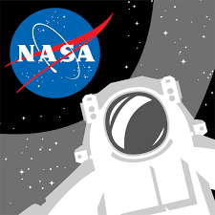
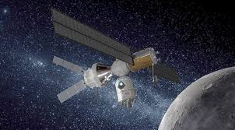
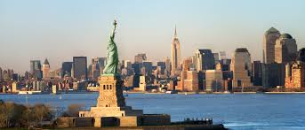
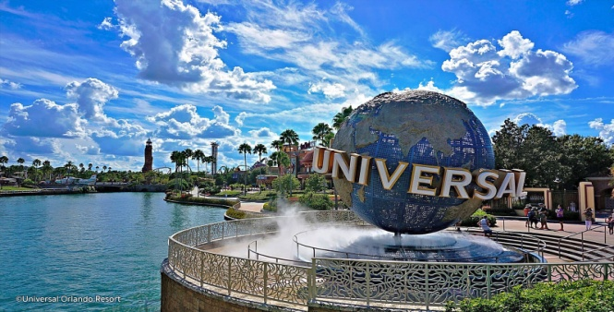
And and Meettttmm

BRIEF ITINERARY ( 11 Nights /12 Days Tour USA with NASA & University)
Day 1:  New York | Arrival at New York International Airport. After immigration formalities, transfer to the Hotel and check in.  Indian Dinner. Overnight at New York.
Day 2:  New York University Visit &  City Sightseeing | After Breakfast Proceed for University Tour of New York for some interactive sessions…Lunch at the meet…afternoon half day tour of New York City to include the Statue of Liberty and Ellis Island …  The Statue of Liberty  Enlightening the World was a gift of friendship from the people of France to the people of the United States and is a universal symbol of freedom and democracy. The Statue of Liberty was dedicated on October 28, 1886, designated as a National Monument in 1924 and restored for her centennial on July 4, 1986.  America's "Golden Door"  They came seeking freedom, opportunity, new lives. Over 12 million immigrants passed through the doors of Ellis Island between January 1, 1892 and November 1954, hoping to achieve the "American Dream". These people have woven their way into the fabric of American life. They have helped create the America we know today. Lunch at Indian Restaurant. Visit Times Square, 5th Avenue, Central Park and Ground Zero Visit the Observation Deck at the Empire State building. Dinner. Overnight in New York
Day 3:  Washington | Transfer to Washington after breakfast. Reach Washington in 4 hours and Go for a Guided tour of the City. Will visit the Air and Space museums, The FBI building, The White house , The Capitol Hill, The Lincoln Memorial, The Washington Memorial, The Korean War Memorial, The Pentagon Etc.  Lunch & ….Check in to the hotel.  Dinner  Overnight is in Washington.
Day 4: WASHINGTON - HERSHEY'S CHOCOLATE FACTORY | Transfer to Buffalo after an early breakfast. Visit the Hersheys Chocolate Factory and then proceed to Buffalo after Lunch. Reach Buffalo by night and check into hotel.  Overnight is in Buffalo. Dinner
Day 5:  BUFFALO - NIAGARA FALLS - ORLANDO | After Breakfast visit the NIAGARA FALLS and enjoy the maid of the Mist experience. After Lunch take the flight to Orlando. Reach Orlando.  Transfer to the Hotel and check in. Dinner. Overnight at Orlando
Day 6:  Kennedy  SPACE CAMP DAY -1  NASA | After an early breakfast we depart for Kennedy Space Centre Nasa. We begin our Space Camp with an orientation given by the Instructors. Western Lunch at the Space camp. Continue session of Space Camp. Depart for Cocoa Beach  Enjoy a swim at the Cocoa Beach.  Indian Dinner…Return to Hotel…Over night at Hotel…
Day 7:  SPACE CAMP DAY 2  NASA | After breakfast leave for Space camp. Enjoy space Camp activities  In the afternoon the group have a lunch with a Astronaut….after lunch the group have the simulator activities at the Hall of Fame  Dinner….Return to the Hotel…overnight at Hotel
Day 8:  UNIVERSAL ISLANDS OF ADVENTURE | Breakfast at the hotel  Depart for Universal’s Islands of Adventure.  At Universal’s Islands of Adventure the world's most cutting-edge rides and attractions make you the hero of your favourite stories, myths, legends, cartoons, comic books and children's tales. You'll join Harry Potter™ and his friends in an unforgettable adventure on the ground-breaking new ride, Harry Potter and the Forbidden Journey™. Battle villains on The Amazing Adventures of Spider-Man®. You'll launch from zero to 40 mph in two seconds flat on The Incredible Hulk Coaster. Plunge down an 85-foot waterfall to escape the jaws of a hungry T-rex on the Jurassic Park River Adventure®. Cheer on the heroes as you enjoy the explosive feats of The Eighth Voyage of Sindbad® stunt show. Help save the day as you hurtle down the Dudley Do-Right's Ripsaw Falls® flume ride. Spin and whirl through the mischievous world of The Cat in the Hat™. It's action, thrills and excitement for all ages… and it's only at Universal's Islands of Adventure.  Lunch included by voucher in the park.  Check into hotel….Dinner.
Day 9:  Orlando –  University of Florida | After Breakfast begin your day with getting a guided tour at the University of Central Florida. You will be shown the campus and all the programs of study. Later go to Epcot center where you can touch the future and travel the world with an amazing array of attractions and live performances. This is an area of 260 acres devoted to past achievements and the future of technology. World showcase offers a kind of permanent World Fair, with pavilions devoted to eleven countries. Lunch at the Meet.  Dinner. Overnight at the Hotel.
Day 10:  Orlando - DISNEYLAND - SEAWORLD | After early Breakfast…Full day visit to either DISNEYLAND or Sea-world .Lunch .at Park…evening Enjoy last moment shopping at FLORIDA Mall….Dinner.-  Overnight is in Orlando
Day 11:  RETURN FLIGHT | Breakfast …Leisure time..Lunch …Check out…. Transfer to Airport for the Departure flight to India

PACKAGE INCLUDES :
- AIR TICKET WITH TAXES ( EX – DELHI ) & USA SECTOR FLIGHTS
- ACCOMMODATION ON TWIN / TRIPLE SHARE BASIS ( 3 STAR CATEGORY )
- BREAKFAST, LUNCH & DINNER
- ALL TRANSFERS AND SIGHTSEEING BY AC COACH
- INCLUDES FIRST GATE ENTRY FEES TO ALL SIGHTSEEING PLACES
- ENGLISH SPEAKING GUIDE SERVICE AT THE DESTINATION AS WELL AS LOCAL GUIDE

VISA ON ACTUALS & AT THE SOLE DISCRETION OF THE CONSULATE

NOTE :

Please be informed all students should abide the specified NASA guidelines including Timings , dress code etc.( it will be specified before the tour )

Basic Tour Plan for National Aeronautics & Space Administration

Suborbital Rockets  - Sounding Rocket Presentation & Video  - Fabrication and Testing Facility  - Range Control Center  - Wallops Island Driving Tour | Orbital Rockets*  - Orbital Partnership Presentation & Antares Launch Video  - H-100 Processing  - Range Control Center  - Horizontal Integration Facility
Wallops Overview*  - Balloon Program Office  - Aircraft Hangar  - Range Control Center  - Fabrication and Testing Facility | Earth Science*  - Aircraft Hangar  - Global Hawk Control Center  - National Oceanic & Atmospheric Administration (NOAA)  - Range Control Center

